**Requirements for the Chocoholic Anonymous System**

A data processing system to support membership and services provided to the chocolate dependent population.

CS 300 PSU WINTER 20’

Professor Chris Gilmore

Group 1

Christian Andersen

Darika Batbayar

James Bao

Minjin Enkhjargal

Yan Li

Deep Patel

Tenzing Rither

# Table of Contents

Table of Contents 1

1 Introduction 1

1.1 Purpose and Scope 1

1.2 Target Audience 1

1.3 Terms and Definitions 2

2 Product Overview 3

2.1.1 Users 4

2.1.2 Stakeholders 4

2.2 Use Cases 4

2.2.1: Requesting Health Services from Provider 4

2.2.2: Viewing Provider Directory 5

2.2.3: Requesting Weekly Reports 6

3 Functional Requirements 7

3.1 Membership Management 7

3.1.1 Register as Member 7

3.1.2 Register as Service Provider 7

3.1.3 Membership Validity 7

3.2 Provide Reports 7

3.2.1 Members Registered to Receive Treatment 7

3.2.2 Management 8

3.3 Billing Information 8

3.3.1 Fees for Services 8

3.3.2 Account Verification 9

4 Non-Functional Requirements 10

4.1 Performance 10

4.2 Security & Compliance with Data Protection Act 10

4.4 Availability/Reliability 11

4.5 Usability 11

5 Milestones and Deliverables 12

5.1 Requirements Document 12

5.2 Software Design Document 13

5.3 Test Plan 13

5.4 Software Completion and Delivery 13

# 1 Introduction

The client has requested a software product to be developed for Chocoholics Anonymous (ChocAn), a system that maintains records and data for members using ChocAn services. ChocAn aims to provide recovery and support services to customers who are addicted to chocolate consumption. The software will maintain customer records and contain functions to update records, billing information and correspondence relating to medical information and invoices.

The requirements document covers the details of the ChocAn software and provide guidelines on important details. This includes: the purpose of the project, important definitions, product overview, functional and non-functional requirements, and milestones.

## Purpose and Scope

The overall goals of the system are:

1. To manage the membership of patients and service providers at ChocAn.
2. To record and maintain services and their fees used through ChocAn.
3. To create reports on use of services and the associated fees upon request and deliver weekly summary to management team at ChocAn.

The sole responsibility of the system is to maintain a valid database of all patients and their records of services provided by health professionals registered at ChocAn. The system is not responsible for checking the validity of transactions between the finance management team and the requested fees by the providers.

## 1.2 Target Audience

The targeted audience includes the ChocAn stakeholders, members, health providers, managers, and engineers involved in developing the software.

1. The developers have to oversee the requirements in order to develop a good product for the customers.
2. Members and providers need to overview the functionality of the product, so they can easily use the software.
3. The stakeholders, ChocAn, need to make sure the product they are paying for is worth it.
4. The managers need to make sure customer needs are being met.

## 1.3 Terms and Definitions

|  |  |
| --- | --- |
| **Terms** | **Definitions** |
| ChocAn | Chocoholics Anonymous is an organization committed to helping people with chocolate addiction. |
| EFT | A record composed of electronic funds transfer data written to a disk. |
| Member | Customer of ChocAn seeking aid from a provider. |
| Provider | Healthcare professional provider. |
| Terminal | Interface to use the software. |
| Provider Directory | Alphabetically ordered list of service names and corresponding service  codes and fees. |
| Service Code | six-digit service code corresponding  to the service provided. |
| Acme Accounting Services | Responsible for recording membership fees, suspending members whose fees are overdue, and reinstating suspended members who have now paid what was owed. |
| ChocAn Data Center | Data center responsible for processing member’s information. |

# 2 Product Overview

The Chocoholics Anonymous (ChocAn) is an organization dedicated to helping people who are addicted to chocolate. Most patients dependent on chocolate do not require dedicated hospital treatment but require special services to help them cope with the urge to continually consume chocolate. These services range from psychiatrists to doctors and dietitians to improve their overall health. Each clinic registered to provide services through ChocAn have variety of distinct services that chocolate dependent population can receive. A patient with a valid membership at ChocAn can drop by any of the clinics or service providers for additional fee according to the treatments they receive. The Chocoholics Anonymous system must therefore be able to manage multiple different memberships and maintain services and their associated fees.

The data processing system required by ChocAn is a membership management system with additional features to keep track of services provided and used by all users with valid membership. The ChocAn system has to provide management with the summary of visits and services used by patients as well as service providers’ detailed information:

1. The recorded information is used to create a summary of services used by a member on a weekly basis.
2. All data associated with a service provider or patients at ChocAn can be requested by management at any given time.

The key features of the system are:

1. *Membership management* Chocolate dependent population can register to become a member for a fixed fee at any time or they may cancel their membership at any time as long as no fees are owed. Special clinics register to become service providers at ChocAn and deliver treatments and support to members for an additional fee. As long as members have no balance owing service providers, their membership remains valid. Each members and service providers are given a nine digit number for identification.
2. *Record services* Service providers offer a variety of treatments. Each treatment received by a member is recorded in database with the date of treatment and its associated fees. Health care specialists at ChocAn can leave comments concerning the patients’ health and well being if desired. A member is given a report on all the receives they received on a weekly basis but this information can be requested at any time.
3. *Generate administrative reports* Each service provider bills ChocAn with a summary of all services given to ChocAn members. The management team at ChocAn receives this summary and compensate service providers for their services. A weekly summary of all fees and services are generated and given to the management team for review.

The overall design of the system has to take into account all privacy concerns. As in all medical and membership systems, privacy is a critical system requirement. It is essential that patient information is confidential and is never disclosed to anyone apart from authorized specialist and the patient themselves.

## 2.1.1 Users

There are two types of users that may make use of the system:

1. *Service provider administrators* The main users that directly interact with the system are administrators who check the validity of the members when they request a service at a clinic or specialist’s office. They enter all services and their associated fees received by the patient to the system. The system stores this information and maintains updated summary of all members. The service providers bills ChocAn with their total fees for their services at the end of the week which is then compared against the data stored in the system.
2. *Operators and management* The operators at ChocAn directly interact with the system to add and remove members as well as service providers. The interactive mode allows the operators to maintain valid and up-to-date membership and records of the chocolate dependent patients registered at ChocAn. A summary of each patient is created by the system upon management’s request and also a weekly summary of all services and fees is provided to the management team.

## 2.1.2 Stakeholders

The following are involved in maintenance and may benefit from the system:

1. *Patients registered at ChocAn* The members registered at ChocAn don’t directly use the system but the system runs reports and sends the summary of their visits weekly. These patients receive information on their recent visits and treatments and hold physical copy of reports generated by the system.
2. Acme Accounting Services The system is required to keep track of fees of every service provided to members by service providers. This information is sent to Acme Accounting Services that take care of the transactions and the system updates the appropriate memberships and reports according to the feedback received from Acme Accounting Services.

## 2.2 Use Cases

These use cases overview how the developed product is used. The following cases showcase some common functions operated on the software. The service provider uses the software to write and access data regarding health services provided by the provider.

### 2.2.1: Requesting Health Services from Provider

Member checks in with service provider to request health services. Member provides service provider with member ID number. The health provider enters member number, date of service and service code correlating to the requested health service. An invoice is stored into the system’s database and provided to the member.

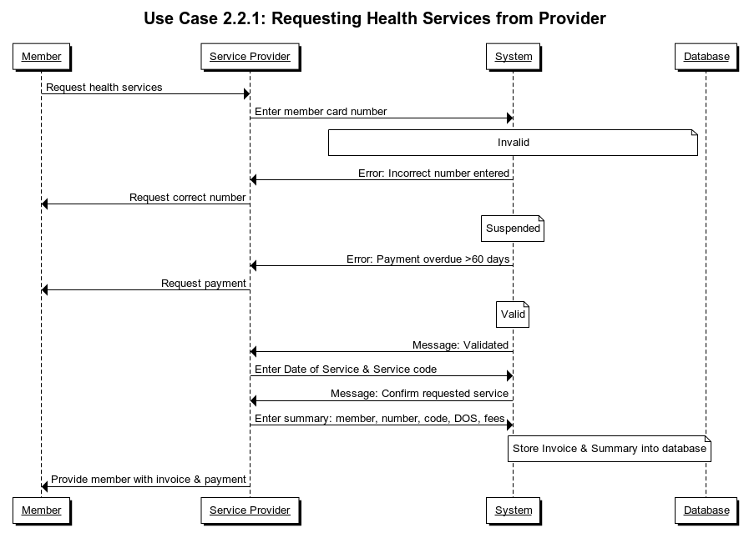

### 2.2.2: Viewing Provider Directory

Service provider uses the system to view the provider directory which contains information of all service names, service codes and fees. The system accesses the file and emails the Provider Directory attachment to the service provider’s email.

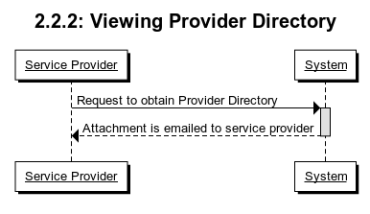

### 2.2.3: Requesting Weekly Reports

Provider uses the system to print or view the weekly report containing a summary of all visits and health services requested by members. There is an automated scheduled printing of reports on Fridays at midnight for service provider manager to view.

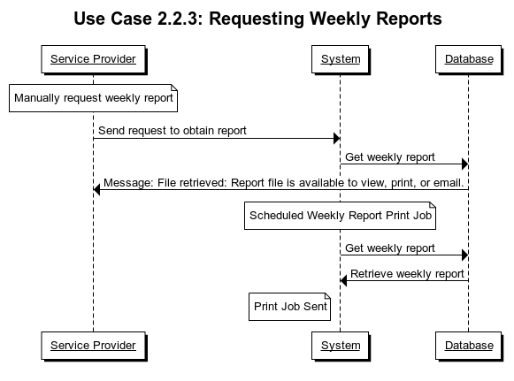

# 3 Functional Requirements

The software must be considered functional, and the following section describes the requirements needed. This includes: modifying, storing, being able to manage and maintain account information, transactions and records.

## 3.1 Membership Management

ChocAn provides an easy to use interface to ChocAn’s providers and members. ChocAn modules, feature providers to access information and charges to members. It allows the provider to edit the provider’s information on ChocAn data center. ChocAn also provides an interface to their service provider members by allowing them to update member’s information, look up used services. ChocAn has a contract with Acme accounting services to process the ChocAn membership fees.

### 3.1.1 Register as Member

A chocolate dependent person may register to become a member to receive a variety of treatments and support offered through ChocAn. When a request to become a member comes in to ChocAn data center, operators add them to the system and provide them with a nine digit membership ID number. The members can terminate their membership at any time as long as there is no fees due.

### 3.1.2 Register as Service Provider

A specialist clinic or an office can register as a service provider at ChocAn. When they register, the operators at the data center add them to the database and provide them with a unique six digit provider ID number. This ID number is used for different services offered by the provider as well as billing information.

### 3.1.3 Membership Validity

Providers can find the member’s information by entering the member id number. The provider terminal communicates with the ChocAn data center to verify if the membership status is valid or suspended.

## 3.2 Provide Reports

The ChocAn accountant must run a weekly report that generates a list of services provided to individual members, both patients and service providers. This report is sorted by service date. ChocAn then sends the report to their members every week via email.

### 3.2.1 Members Registered to Receive Treatment

Every week, the members that used the services provided by any service providers receive a summary of their visits and fees. This summary includes:

1. Member name
2. Member number
3. Member street address
4. Member city
5. Member state
6. Member zip code
7. Details of services provided
   1. Date of service
   2. Provider name
   3. Service name

### 3.2.2 Management

The management team at ChocAn can request a summary of members’ visit or all services provided by a service provider at any given time. This report includes a total fee of all services received and provided by the particular member the management is interested in.

## 3.3 Billing Information

The system is not required to process any fees but simply store information on all fees associated with services which gets sent to a third party financial institution, Acme Account Service. The system also keeps track of how much each patient owes and the amount to be paid to service providers.

### 3.3.1 Fees for Services

Chocolate dependent people can register to become a member for a fixed fee. Any other treatments and support they receive through ChocAn has additional fee. The system processes the information entered by the service provider on what the services were and how much each treatment cost.

The service providers enter the following information for record:

1. Current date and time (MM-DD-YYYY HH:MM:SS)
2. Date of service (MM-DD-YYYY)
3. Provider number (9 digits)
4. Member number (9 digits)
5. Service code (6 digits)
6. Comments ( 100 character)

The providers send the following information to ChocAn to request payment for their services:

1. Provider name (25 characters)
2. Provider number (9 digits)
3. Provider street and address (25 characters)
4. Provider city (14 characters)
5. Provider state (2 letters)
6. Provider zip code (5 digits)
7. For each service provided, the following fields.
   1. Date of service (MM-DD-YYYY)
   2. Date and time received by the computer (MM-DD-YYYY HH:MM:SS)
   3. Member name (25 character)
   4. Member number (9 digits)
   5. Service code (6 digits)
   6. Fee to be paid (up to $99,999.99)
8. Total number of consultation with members
9. Total fee for the week (up to $99,999.99)

### 3.3.2 Account Verification

Acme Account Services is responsible for financial procedures such as processing membership fees for memberships and services for both patients and service providers. The system only updates the membership information based on a successful payment validity provided by Acme.

# 

# 4 Non-Functional Requirements

Nonfunctional requirements set requirements for how a system should be operated. It states the different aspects of the system judges the performance. In this section, it describes the system of the ChocAn system in terms of performance, scalability, capacity/memory, availability/reliability, encryption/data integrity and usability.

## 4.1 Performance

Performance is gauged on how well can the application run on different platforms and in different ways. The gauge used at measuring this can be the response time for processing patient and provider summary reports are generated weekly. The correct amount of credit is transferred to each provider’s corresponding bank account weekly. All the file of services within that week are read and printed as a number of reports at the ChocAn Data Center every midnight on Friday. ChocAn memberships are added, deleted and edited promptly during the day. By 9pm each evening the memberships’ information are updated by the Acme computer.

## 4.2 Security & Compliance with Data Protection Act

It is important that security standards are met. The application shall be written in (a) programming language(s) that allow the data and databases we’re working with to be encrypted. That way it won’t get corrupted on the systems that this app will run on. Security ensures the safety and integrity of the software. To meet a set of security standards the following will be true:

1. Only members can view their own transactions and account information to maintain patient confidentiality.
2. Managers have permissions to edit and view member’s/provider’s records
3. Memberships are verified for patients. Each registered ChocAn member receives a card with the member’s name, a nine-digit member number and it is encoded on a magnetic strip. A member has to pass authentication every time when he or she wants to access care.
4. Records meet HIPAA policies and procedures

The software and data collection of patient records comply with the HIPAA Privacy Act. The software must maintain the privacy and security of health information in a secure database. The transferring of documents relating to any patient health information electronically is done through secure portals. Any data collected relating to specific patient information is not sold. Access to patient records and data are not given to non-authorized parties.

**4.3** **Record Database Data Types**

The data that is stored include data on the service bill and patient record. The format, data type and data size are displayed in 4.3.1 and 4.3.2.

**4.3.1 Addiction Service Bill**

Each data entry for an addiction therapy session/service bill takes up a finite amount of memory in the database and in the application- current date & time [int + char string], date of service [int + char string], provider number [9 int string], member number [9 int string], service code [6 int], comments [100 char]- all of this data for every 1 entry. This is different from the record of addiction service(s) that exists for each patient (see 1.3.2)

**4.3.2** **Addiction Patient Record**

Each data entry for an addiction patient takes up a finite amount of memory in the database and in the application- Member name (25 characters), Member number (9 digits), Member street address (25 characters), Member city (14 characters), Member state (2 letters), Member zip code (5 digits), plus an array of “service” structures.

For each service provided (each “service”), the following details are required: Date of service (MM-DD-YYYY), Provider name (25 characters), Service name (20 characters).

## 4.4 Availability/Reliability

The system is available for ChocAn members and providers. As long as the member pays a monthly fee, then he can access the system to seek for medical services and advice.

In terms of billing, the system has a specific member ID set up for the members so it ensures the right patient to be billed. The providers also has a Provider Directory to look up service codes for billing so that provides accuracy. It would show the name of the service corresponding to the service code on the provider’s computer terminal for verification. However, if an incorrect code’s entered, then an error message would result. Furthermore, the providers get their payments recorded on a disk and later transferred to their bank accounts via banking computers.

The ChocAn Data Center updates membership information daily.

Lastly, the summary reports for members and providers are written and saved as their own files.

## 4.5 Usability

The product aims for user friendly interface to provide users with the best experience. The healthcare professionals and others can easily understand the product, since they may not be knowledgeable about the software side. Unit testing is implemented to check for errors to provide uninterrupted usage of the product as much as possible. In addition, it is essential to maintain the product with quality code to avoid error messages. The ease of usability is focused on the experience of service providers using the system.

The providers are given a specially designed ChocAn computer terminal that asks them to enter his or her provider number. There are a few steps that the providers need to take to bill the patient. The providers need to enter the current data, date of service, service code, provider number, member number and optional comments in a form on the computer terminal. A summary report for the service is also emailed to the providers on a weekly basis. Once it’s filled then the information is saved to be processed. Also, the providers can request the software product for a Provider Directory which is sent in an email.

# 5 Milestones and Deliverables

This section will define key dates, which outline progression through the projects lifetime. Each date represents measurable progress that will be used to assess project completion and to provide products to be reviewed by the customer. A requirements document, design document, and test plan will outline the key points in the project lifecycle and provide products to be reviewed by the customer. Upon customer approval the project will then be designed as outlined and be available to the customer for use with a full project report. The requirements document will be delivered to the customer on January 27, 2020, the design document will be completed by February 10, 2020, the test plan will be completed by February 24, 2020, and the software will be delivered as defined by the requirements agreed upon to ChocAn on March 13, 2020.

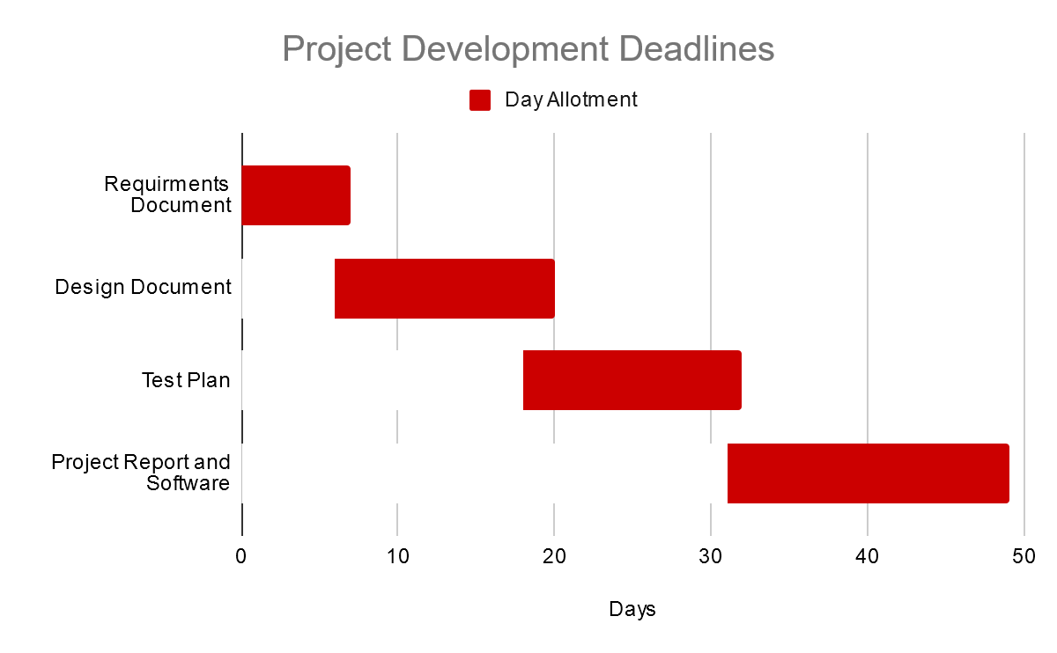

## 5.1 Requirements Document

A requirements document will be created based off information provided by ChocAn. This document will provide the specifications for the software being developed, and serve to provide an agreement to produce software within customer requirements and expectations. The requirements document will be provided to the customer for review and approval by January 27, 2020.

## 5.2 Software Design Document

A design document will be created outlining the software structure, data structures, interfaces, and component reuse and design if applicable. This document will define how the software is developed as a whole to support the pre-identified requirements, the data structures required to provide acceptable performance and security, the component relationships, and potential component recycling. The software design document will be completed by Feb 10, 2020.

## 5.3 Test Plan

A test plan will be created outlining procedures that will ensure the software meets the requirements identified by ChocAn. Each software feature will be tested to ensure functional requirements are met. Component interaction will also be tested to ensure software integrity. Testing will attempt to force the software to experience unexpected behavior. These tests will ensure the software is validated, verified, and fully operational for customer use. The test plan will be completed by February 24, 2020.

## 5.4 Software Completion and Delivery

The software will be completed and developed to requirements specified by ChocAn. Software documentation will be produced including a presentation outlining software features, testing results, and known issues. All components will be delivered in an acceptable working state to ChocAn, for use as specified, by March 13, 2020.